Computer Language Coding Concepts

Creation Behavior Of Sub-Commands in a Diagram
The creation behavior of sub-commands was already explained in the article Creation Behavior Of Sub-Commands. The current article demonstrates the concept in a diagram.

The steps of creation of a sub-command are clarified with diagrams. This creation behavior applies to both sub-commands inside an active parent commands, as well as sub-commands of an inactive parent command, because an inactive command can also be refenced by an active command, that is allowed to be run after all.

At first, the parent command is in the current state:

- The parent command is already created:

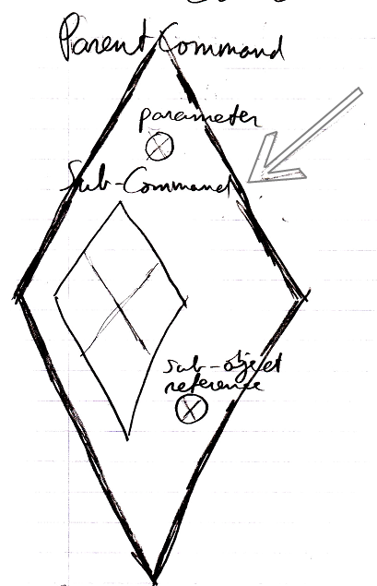

- The parent command’s own parameters / public contents are also already created:

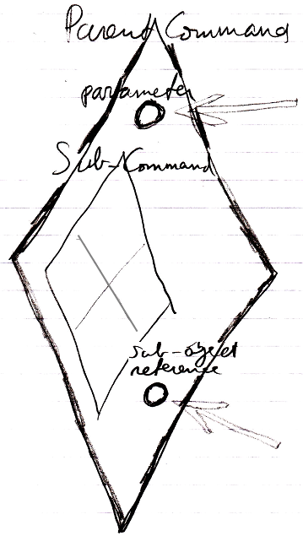

- The parent command’s own parameters are already filled in:

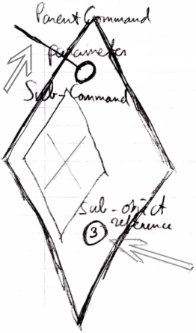

- And the parent command’s private objects are also created.

Before the parent command is run, the following happens:

- All sub-commands are created (which is actually private content too)

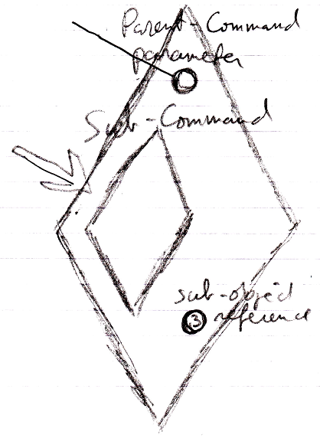

- The sub-commands’ parameters / public contents are there, but left empty:

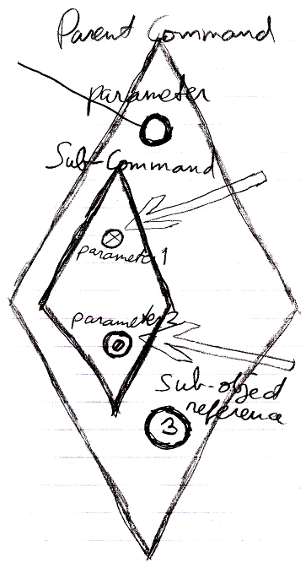

Reference parameters and object out parameters are Nothing (first arrow), value parameters are created and initialized with a default value (second arrow).

- Mind, that the sub-command’s private contents are not created, which includes its private objects, command calls and clauses.

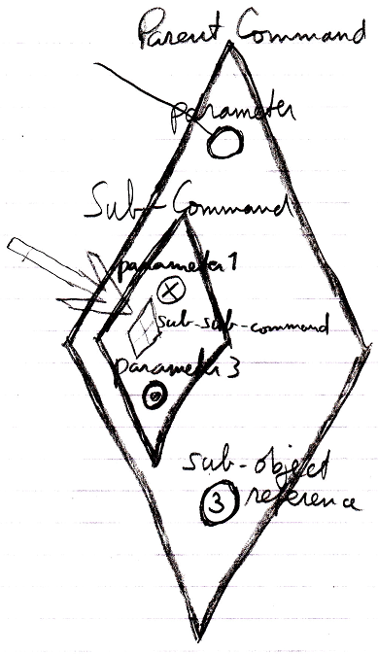

- Parameters passings are created, which are assignments to sub-commands’ parameters, that reference sub-commands’ empty parameters.

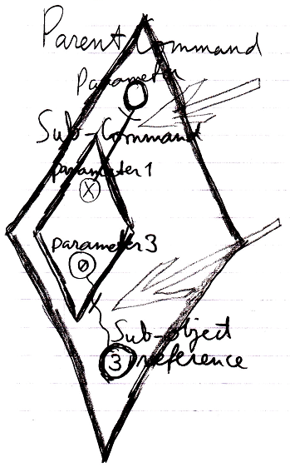

Yes, the parameter passings look like references, but they are not; they are assignments. Parameter passings have an implicit notation, that look like references. They have to be assignment, not references, because after the command executes, the parameters are actually destroyed.

Only now, the parent command is ready to run. The sub-command’s public content needed to be created in order to instantiate the parameter passing assignments, part of the parent command.

See also: Creation Behavior of Sub-Commands, Commands

Author & Copyright: Jan-Joost van Zon Date: August 2, 2008 – August 13, 2008 Location: Oosterhout, The Netherlands Status: Finished

